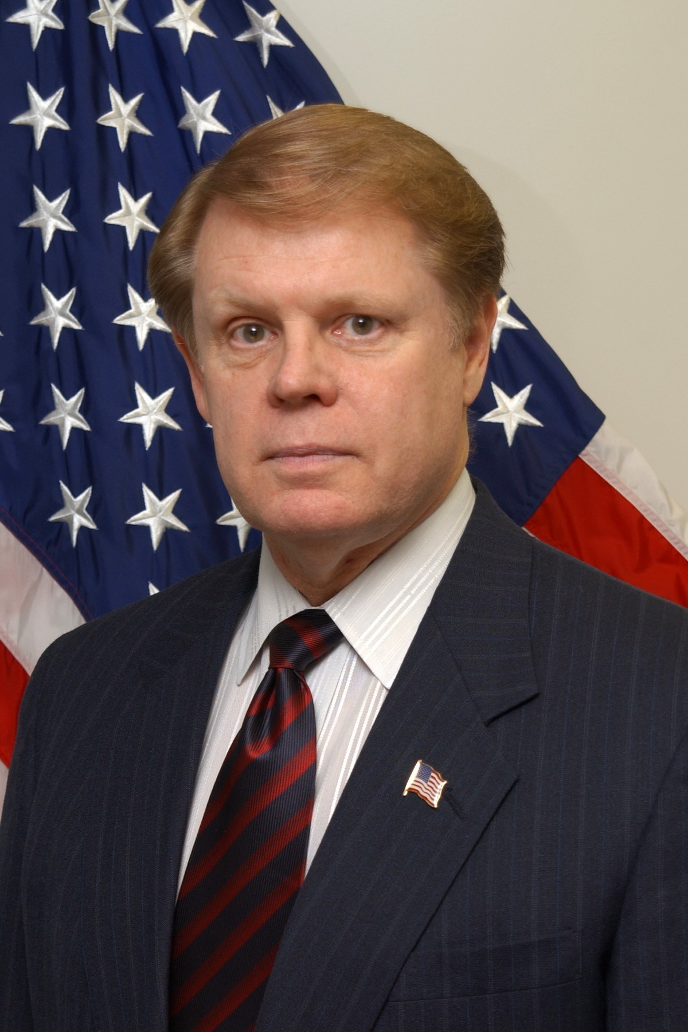
Biography
Randall D Headrick

Randall D. Headrick is the CEO of Headrick Partners, LLC, a Small Veteran Owned business dedicated to providing help and guidance to defense industry partners doing business with federal state and local governments, and specifically the Air Force, Army and The National Guard. Headrick Partners specializes in emergency communications, and incident site communications restoral for all first responders.

Mr Headrick is the former Air National Guard (ANG) Director of Communications and Information (A6), and the Chief Information Officer (CIO). His national awards include being named one of the "CIO 100" by CIO Magazine in 2007, and one of the "Computerworld 100" by Computerworld magazine in 2008 for his innovations in emergency preparedness and first responder/ incident site communications.

As the ANG/A6 and CIO, he was the principal advisor to the Director Air National Guard on Communications, Information Technology, Information Management and Air Traffic Control Systems. He provided the Air National Guard with an enterprise approach to all information technology lifecycle activities. Mr. Headrick’s responsibilities included oversight of both fixed and tactical Air Traffic Control (ATC) and Tactical Communications Squadrons, as well as the satellite and terrestrial networks that service the 250 locations and 107,000 members of the Air Guard. He provided complete direction and oversight of the ANG’s $250 million dollar enterprise network, including strategic planning, capital planning and investment control, policy and standards, resource planning, knowledge management, architecture and infrastructure planning, and security management.

From 2002 through 2005 Mr Headrick was assigned as the Deputy Director for ANG C4 with responsibilities for all Air Traffic Control Squadrons and all Tactical Communications units assigned to the Air National Guard. His duties included the procurement and sustainment of all ATC and Communications equipment, coordination with appropriate Air Force agencies, and management of the programming and funding process.

From 1991 through 2002 Randy was assigned duties as the Chief, Air Traffic Control Systems for the Air National Guard with responsibilities for all ANG Air Traffic Control systems and personnel.

From 1972 through 1990 Randy was a member of the Air National Guard and was assigned to various Headquarters positions in Missouri and Texas, he was responsible for both the people and equipment that made up the Air Guard ATC community. Randy was an Air Force Air Traffic Controller from January 1966 through January 1972.

